**Software Installation and Usage**

1. **Install the App**

Follow the on-screen prompts to grant the app permissions to access your phone’s "discover nearby devices," "microphone," and "camera" features.

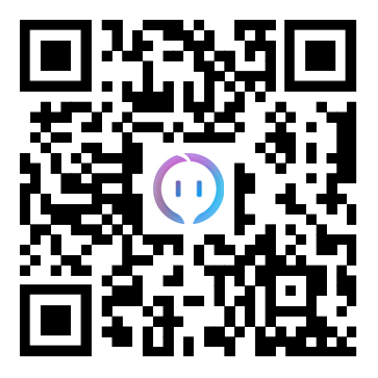

Otik Android



Otik IOS

1. **Registration and Login**

Launch the app and enter the login screen. Register using your email or phone number to receive a verification code. Enter the code to log in (valid for 5 minutes).

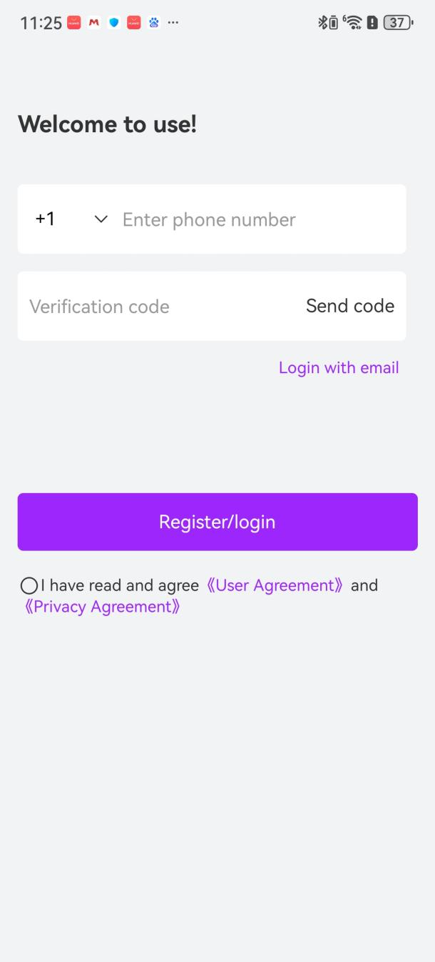

1. Activate Headphone Bluetooth  
   Open the headphone case to automatically turn on the headphones’ Bluetooth.
2. Pair with Phone Bluetooth  
   Go to your phone’s Bluetooth settings, search for available devices, and pair/connect to the headphones.

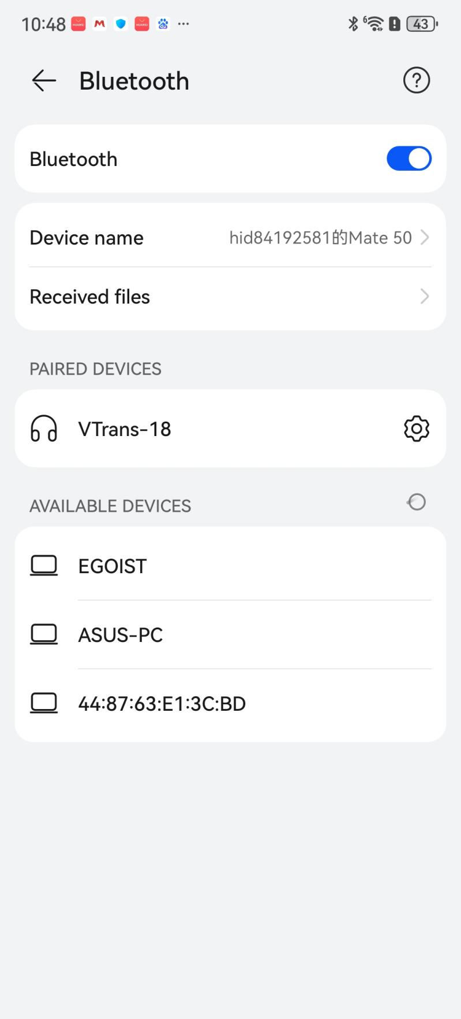

1. Bind Your Device  
   Once your phone is connected to the headphones, log in to the app. The headphones will automatically bind to your account, and the bound device name will appear on the app’s home screen.

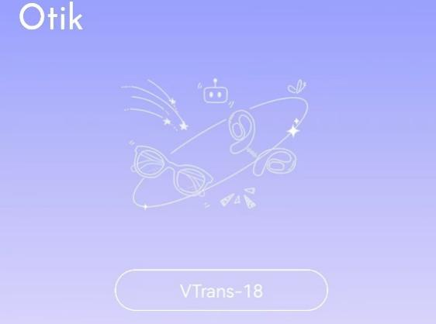

1. Using Translation Features  
   Select a translation mode based on your scenario and choose the source/target languages. Three modes are available:

* Free Talk Mode  
  For two people: Each wears one headphone. Click/double-click the headphone until you hear a beep to start speaking. Translation plays in real time through the headphones. Recording stops automatically 3 seconds after speech ends (configurable).

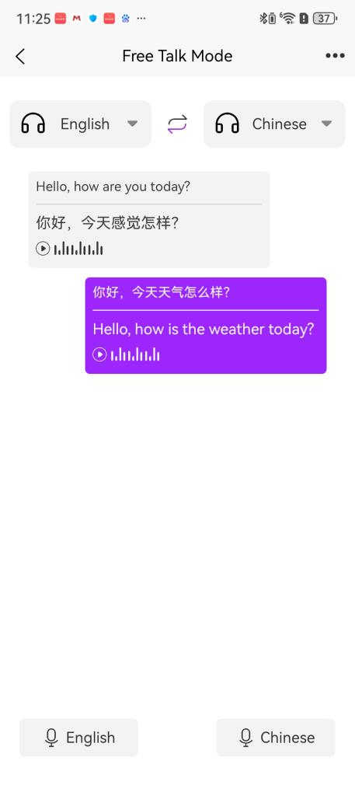

Speaker Mode  
For one person using headphones and another using the phone:

Headphone user: Click/double-click the headphone (after a beep) to speak. Translation plays through the phone speaker.

Phone user: Tap the microphone button in the app to speak. Tap again or wait 2.5 seconds (configurable) after speech ends. Translation plays through the headphones.

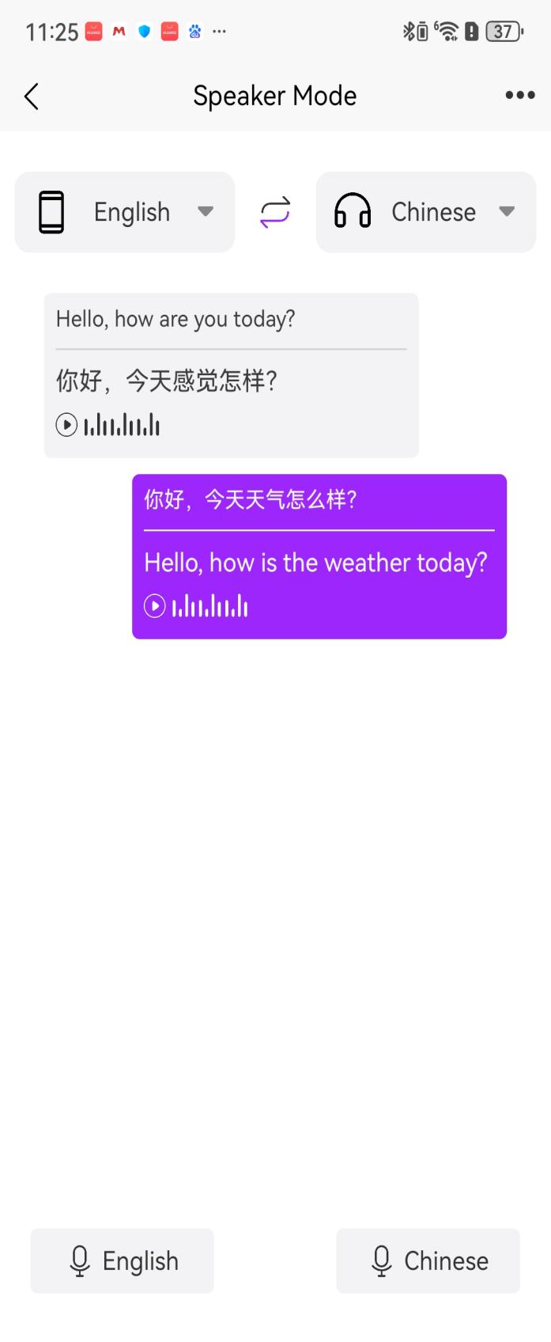

Translator Mode  
Hold the microphone button in the app to speak. Release to stop recording. Translation plays through the phone speaker.

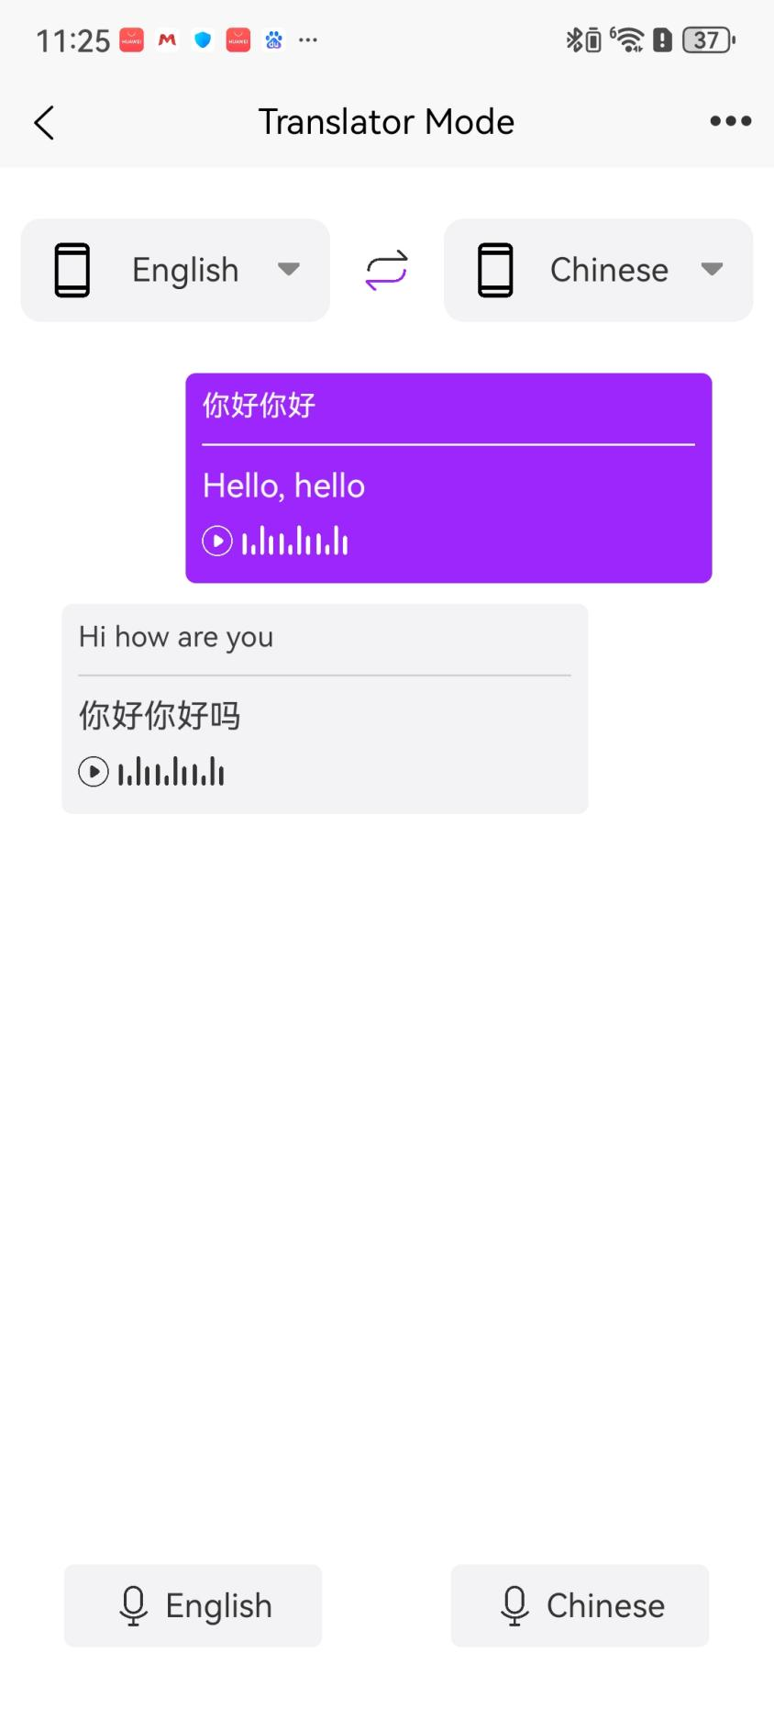

Translation Settings

Tap the "…" button in the top-right corner of each mode to adjust settings.

Auto-End Recording: Stops recording/translation when speech pauses for a set time (configurable).

Auto-End Interval: Adjust the pause duration (in seconds) before recording stops.

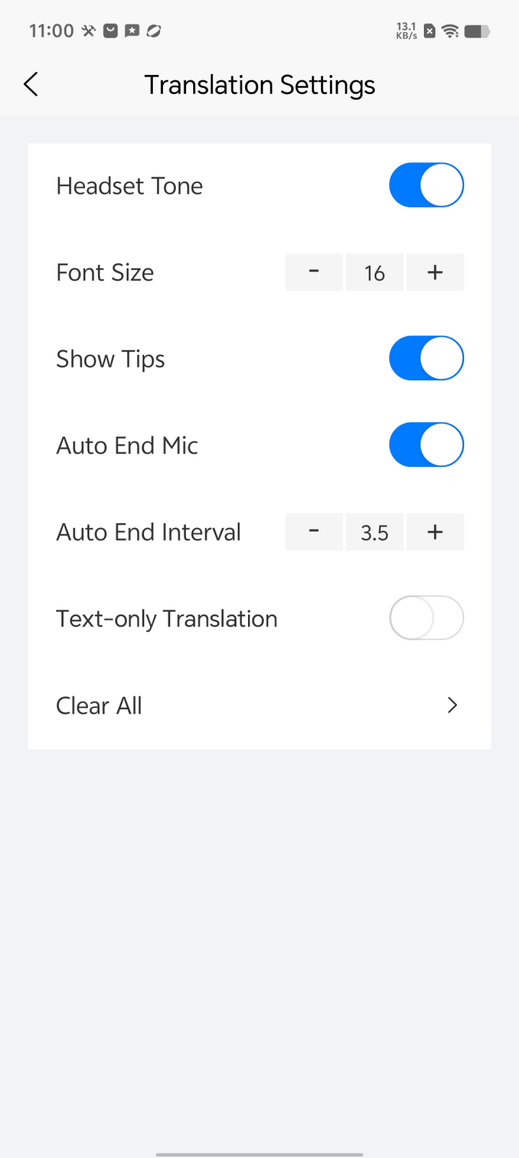

**Troubleshooting**

1. **Connection Issues**: Ensure the earbuds are in pairing mode and Bluetooth is enabled on your phone.
2. **App Download Issues**: If the QR code does not work, open it in your phone's browser to download the app.
3. **Inaccurate Translation**: Ensure clear and accurate voice input.
4. **App Lag**: Close unnecessary background apps to free up memory.
5. **Low Volume**: Adjust the media volume in your phone’s settings.
6. **App Updates**: Regularly check for app updates to ensure optimal performance and security.
7. **Translation Failure**: Check the connection status. If translation still fails, try re-logging into the app or contact customer support.

**Account Binding: The earbuds need to be bound to an Otik app account to function. Unbind from the current account before switching to another one.**